SculpSure™ Laser Fat Reduction

SculpSure™ is a laser-guided non-invasive body contouring system for the reduction of stubborn fat in areas such as the abdomen and love handles. The 25 minute procedure destroys up to 24% of treated fat cells without surgery. It requires no needles, no anesthesia, and no downtime.

How does SculpSure Work?
During a SculpSure™ treatment the device is placed directly on your treatment area(s) and allows the heated energy to penetrate your tissues. You experience no pain during the procedure and can just lay back and relax for about 25 minutes. The heated laser energy essentially melts your fat cells, causing them to break away from your other tissues. Once the fat cells have released, your body naturally removes them. The results will show up within 6-8 weeks with optimal results at 12 weeks.

Benefits of SculpSure
SculpSure™ has been proven to be highly effective and includes the following benefits:
- Pain free
- Non-invasive
- No downtime
- 25 minutes per area of treatment
- Treatment area is 4 individual areas the size of the palm of your hand each, placed as needed
- Multiple areas can be treated in the same session
- Only requires one treatment to achieve a reduction of 24% or circumferential reduction of about 2 inches.
- FDA-approved

Why choose SculpSure compared to cooling devices?
- Pain free
- No need to massage the area post treatment
- Even fat reduction distribution, no lumps
- Significantly shorter treatment time (25 minutes vs. 2-4 hours)
- Multiple areas can be treated in the same session.

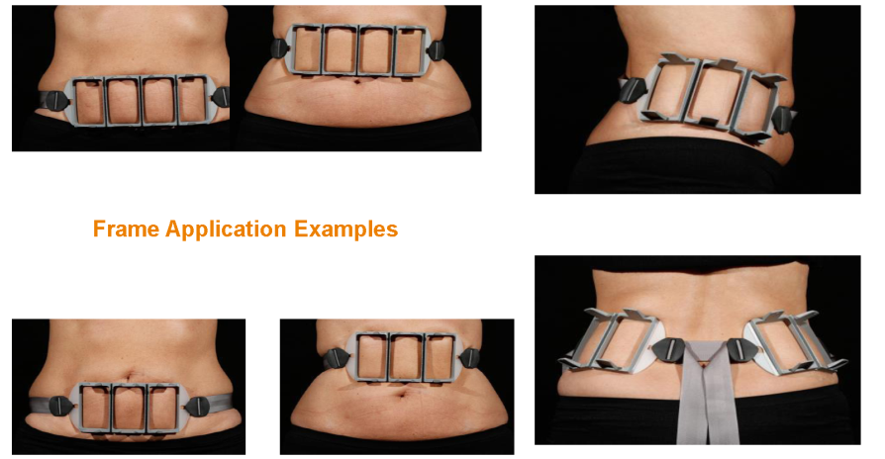
6cm

4cm

SculpSure
Time | 25 minute treatment using 4 applicators simultaneously
Technology | Laser Thermolipolysis (heats the fat) with cool flat applicator
Treatment Area | One treatment area = 4cm x 6cm x 4
Recovery | No recovery time. Can work out immediately after / minimal tenderness in area treated
Comfort | Hands free/ flat non-suction applicator with cooling plate that is easily tolerated. No suction, no pulling the tissue. Minimal treatment discomfort. No post treatment pain.
Candidates | Men and women can treat all body types and ages. Ideal candidates are 5 to 15 pounds within your ideal weight and 30 BMI or less.
Areas | Treat multiple areas at once and applicators can be placed on the body in many configurations to better target trouble fat cells
Skin Laxity | Not indicated for skin laxity alone, however treated areas of fat contract without additional skin laxity.
Efficacy | Up to 24% permanent reduction in fat in 6-12 weeks
Treatable areas | Abdomen, flanks (love handles), inner and outer thighs, above the knees, bra line, back of neck or other fat deposits
Results | Smooth treatment result due to heat dispersion and feathering of surrounding fat outside of the applicators. Final results visible 12 weeks after the last treatment in a recommended series.
# of Treatments | A minimum of 2 treatments, 6 weeks apart, are recommended. Multiple treatments may be required to achieve desired results.
Cost | $1,000 average cost per treatment area (4 applicators). Multiple area and treatment packages available.
Weight Loss | SculpSure is NOT intended for weight loss. It is intended to treat localized areas of fat. It is best performed in conjunction with healthy eating and exercise regimen or as part of a weight loss program.
# of Applicators | Cost per  applicator
8-16 | 250
20+ | 180

FAQ'S
What is SculpSure?
SculpSure is a non-invasive body contouring system for the reduction of stubborn fat in areas such as the abdomen and love handles. The laser energy in SculpSure selectively absorbs into fat cells and heats them up to a specific temperature which is ideal for destroying the fat cells. The body then flushes the destroyed tissues through its natural processes. This process takes approximately 6 weeks.
Is SculpSure right for me?
SculpSure is ideal for people with trouble spots, particularly those that seem resistant to diet and exercise.

How much fat reduction can I expect?
One treatment destroys up to 24% of the treated fat cells. Further fat reduction is achieved with a recommended multiple treatment protocol.

How many treatments will I need?
Most patients see results with as little as two treatments six weeks apart. Two to three treatments are average. Additional treatments may be required to achieve desired results. Ask your treatment provider about the best treatment plan for you.
What should I expect during the treatment?
Most patients feel a tingling sensation intermittently throughout the treatment which is generally well-tolerated.
When will I see results?
Many patients start to see results as early as 6 weeks following treatment as the body begins to evacuate the destroyed fat cells, with optimal results at 12 weeks after the last treatment.
How long will the results last?
Treated fat cells are permanently destroyed during the treatment and will not regenerate.
How long before I can resume normal activities?
There is no downtime with SculpSure, so you can have the treatment during your lunch hour and return to work immediately.
What is the difference between fat loss and weight loss?
The number of fat cells stored in our bodies typically remain constant throughout adult life. After the SculpSure treatment, the destroyed fat cells will never return. However, as we lose weight, the size of fat cells become smaller, but typically do not decrease in number. Even with diet and exercise, many people have difficulty losing weight in certain trouble areas.

How do I prepare for my SculpSure treatment?

It is recommended to drink plenty of water before your treatment and continue drinking after treatment. This helps your system “flush out” the destroyed fat cells.

PRE / POST-TREATMENT INSTRUCTIONS
Pre-treatment instructions:
- No sun exposure 7 days prior to the treatment.
- Increase hydration to 64 fluid ounces of water per day for at least 3 days before treatment and one week after treatment. Limit processed foods.
- Remove all creams or oils prior to treatment.
- Shave the area to be treated 24 hours before the procedure (if needed).
Post-treatment instructions:
- May experience mild pinkness or redness, tenderness, swelling, pain, itching, and skin firmness.
- Tenderness may last up to two weeks and in some clients a bit longer.
- Use a cold compress and/or acetaminophen to help relieve tenderness.
- Gently massage the area twice a day for 5-10 minutes.
- May resume normal daily activity including exercise immediately post- treatment.
- Encourage proper hydration (64 oz of water per day for 7 days) and light physical activity to help eliminate fat via the lymphatic system.
- Reduce sugar, dairy, sodas (diet or regular) and high glycemic index foods such as cereal and white flour products and processed foods. Increase raw vegetables and natural foods.
- Results are gradual and no demarcation lines of treatment are visible. Treatment results should be assessed 10-12 weeks after the last treatment.
- Contact your physician if you have any concerns about your treatment areas such as increasing tenderness or swelling several days after your treatment, or if you develop blisters, hardened areas or nodules.
your SculpSure™ appointment is scheduled as follows:

Provider: ______________________

Date: _________________ Time: ___________ AM / PM

Procedure Duration 30 min 60 min 90 min 120 min

Treatment Cost: $ __________

Deposit Collected: $________

Balance Due 48 hours prior to procedure $______________

by: _______________
Since this is a long appointment, full payment and
48 hour cancellation notice is required.
Same day cancellation fee is $500.

SculpSure Treatment Plan

Name: ______________________________________________________________

Age: ______ Sex: F M Height: _______ Weight: _______
Which body area/areas would you like treated?
(mark on body map)
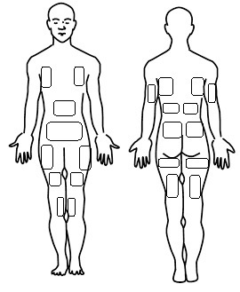

Area | Recommended  # of Frames | Anticipated  # of Treatments  Multiple treatments may be required to achieve desired results. | Cost  8-16 applicators $250 per Applicator  20+ applicators $180 per Applicator
Upper Abdomen
Lower Abdomen
Flanks
Bra Line
Back – upper
Back – mid
Back – lower
Arms
Thighs – inner
Thighs – outer
Thighs – front
Thighs – Back
Total Frames:
Number of Treatments:
Total Cost: |  |  | $
By:_________

