Stretch Marks (Striae) – ResurFX® Laser

During ResurFX® laser treatment, the fractionated laser handpiece is guided across the skin emitting laser energy that penetrates the outer skin layers. Collagen beneath the skin is stimulated encouraging collagen remodeling, repair and growth. The repair of these middle-skin fibers helps provide a smoother appearance and reduction in visible stretch marks. The treatment typically lasts under 30 minutes, and there is minimal to no downtime after the procedure.
Depending on the extent of stretch marks and the areas being treated, the most optimal results with ResurFX® laser treatment can be obtained with a series of four to six treatments spaced 4 weeks apart.
Please be aware that pre and post- care are under your control and a direct effect on the success of healing and end results of stretch marks with laser.
Before the Laser Treatment
Avoid sun exposure, self-tanning products, and tanning beds for at least two weeks prior to laser treatments.
Wear comfortable clothing, making sure not to irritate the treated area.
Arrive for your treatments 45 minutes prior to scheduled appointment to apply topical anesthetic cream which helps reduce discomfort during treatment.
Please notify your treatment provider if you are on any antibiotics or other photosensitive medications, or have a history of post-inflammatory hyper pigmentation.
After the Laser Treatment
There may be some discomfort associated with treatment.
A burning/itching sensation may last for up to an hour after treatment, which is tolerable.
Temporary edema (swelling) may appear immediately following the treatment which typically resolves within 24-48 hours. The erythema (redness) may last up to 2-3 weeks.
Cold packs and OTC 1% Hydrocortisone may be applied twice a day first 2 days.
Gentle wash or mild cleanser may be used, avoiding soaks in the bath tub and scrubs the first 7 days.
You may resume normal daily activities immediately following the laser treatment.
There is a small possibility of changes in the texture and pigmentation of the skin (hypo- or hyper-pigmentation), which usually resolves in three to six months. These are usually temporary and rare. Sometimes a cream may be necessary to help fade pigmentation, and the cost is your responsibility.
Avoid direct sunlight, wear protective clothing, and use 30-50 SPF sun block daily throughout the treatment process (6 months) to prevent hyper pigmentation.

Treatment Areas:
One Area =
x 2
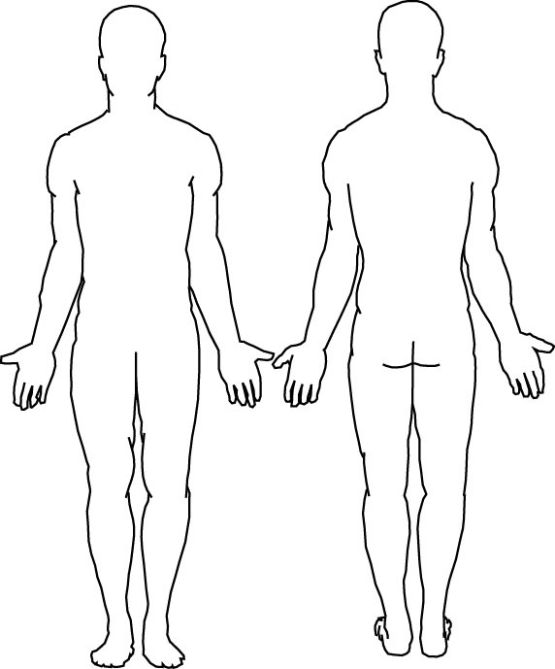
$350 Per Treatment of One Area
Packaged Treatment Formula:
$350 x _______ x 0.90 x ______ x ______ = $_______
# of multiple # of 0.95
treatments treatment Areas multiple
discount area discount
4 Treatments, 1 Area $1,260 (Save $140)
4 Treatments, 2 Areas $2,394 (Save $406)
4 Treatments, 3 Areas $3,591 (Save $609)
Questions? Please call our office at (818) 505-9300

